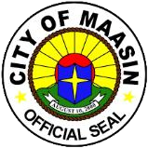
Republic
of
the
Philippines
Province
of
Southern
Leyte
CITY
OF
MAASIN
*
CITY
PROJECT
MONITORING
COMMITTEE
POSTACTIVITYREPORT
ACTIVITY: | Coordination Meeting Evaluation Of SubayBAYANI And LPMC Assessment Results
DATE: | July 30, 2026
VENUE: | Department of the Interior and Local Government Province of Southern Leyte, City via Zoom
NO. OF  PARTICIPANTS: | All PMC Members, Others:

REPORTSUMMARY

- OBJECTIVES OF THE ACTIVITY:
The conduct of the activity is designed to:
  - To identify areas for improvement based on the results of the SubayBAYANI Awards assessment;
  - Discuss strategies to further enhance the performance and functionality of the Local Project Monitoring Committee;
  - Provide guidance on the proper accomplishment and timely submission of the Regional Project Monitoring and Evaluation System Forms and other project monitoring requirements.

- HIGHLIGHTS OF THE ACTIVITY:
- | LPMC Functionality Assessment Tool
- | Discussion of the parameters of Organization, Training, Planning, Implementation of meetings and Inspection.
- | Emphasize the MOV that needed to submit every quarter.
- | Discussion the project life cycle.
- | The revised RPMES report preparation and also the revised frequency of reporting and timeliness.
- | The road classification

- OUTPUT/S OF THE ACTIVITY:
- | Successful activity

- RECOMMENDATIONS/SUGGESTIONS
- | All RPMES form will be fill up and submitted it quarterly.

- REQUESTED ACTIONS (if any):
none
- Attachments (check as applicable):
_√_Photos ___Program of Activities
___Powerpoint/lecture _√_Certificate of Attendance/Participation/Completion
___Materials/Brochurs ___Others, pls specify _________________
___Workshop/activity materials

PICTORIALS
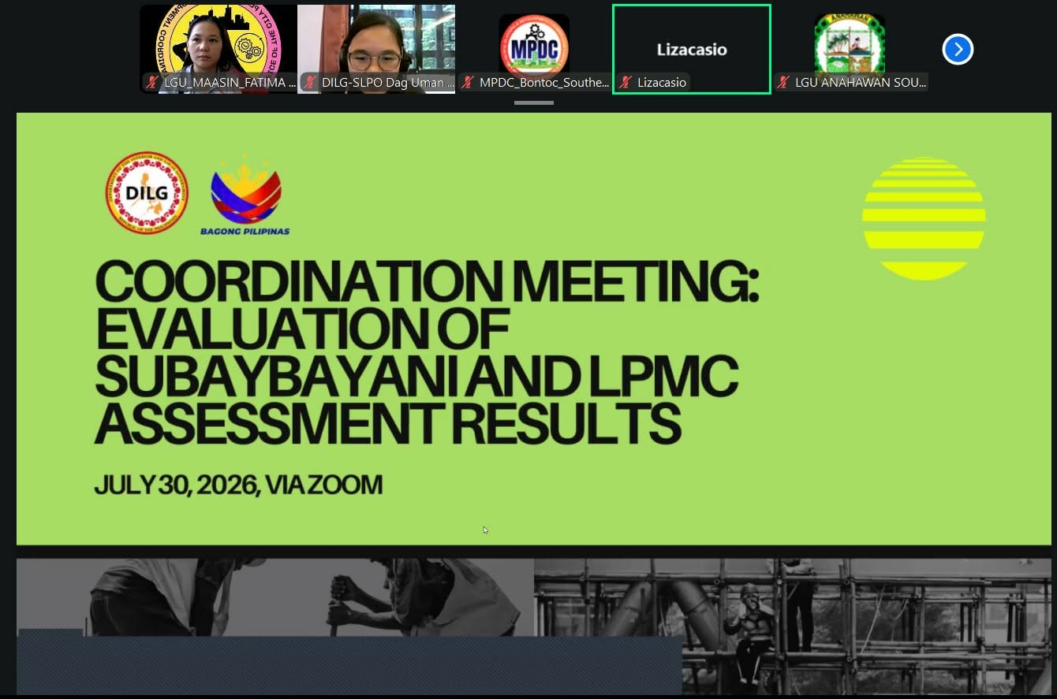



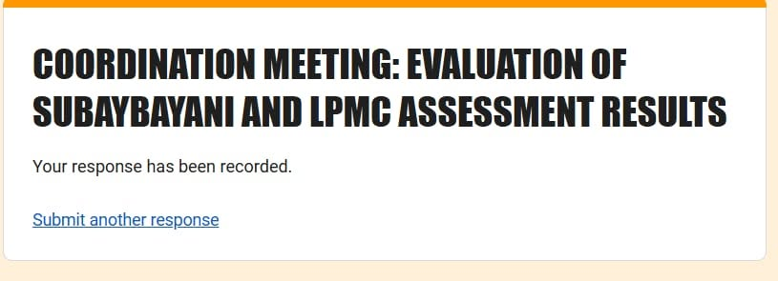

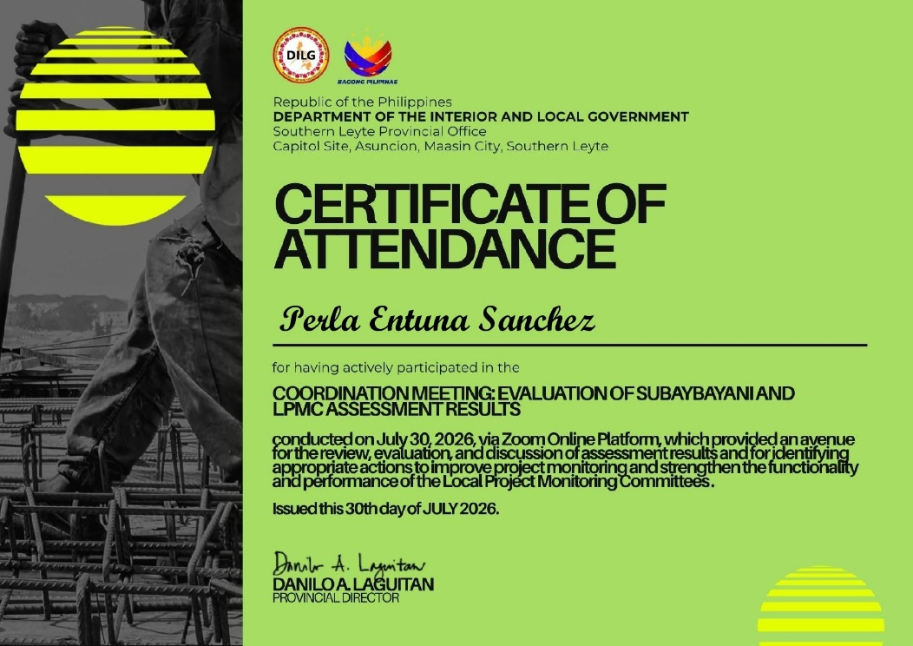

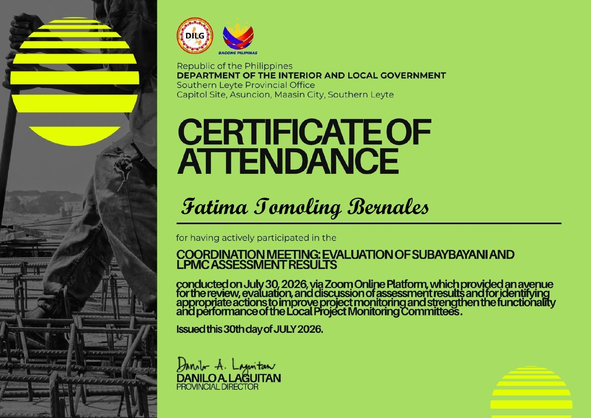

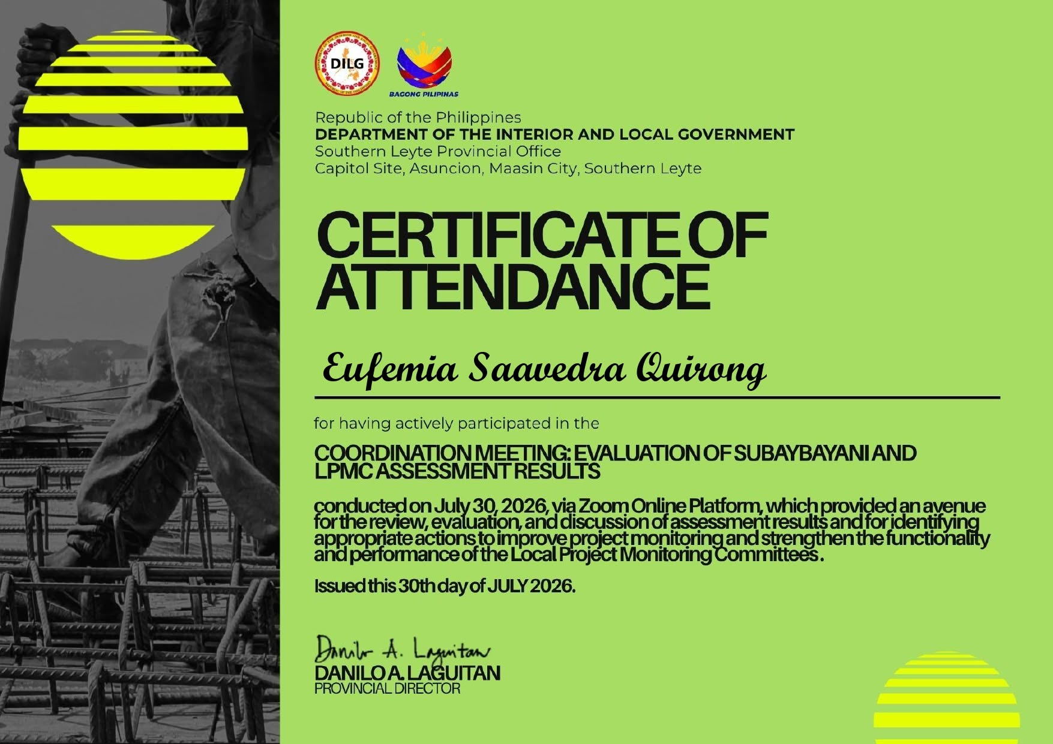

Prepared by:    FATIMA T. BERNALES  CPDO Staff  PMC Ass. Secretariat |   Submitted by:  ENGR. EUEMIA S. QUIRONG  ENGINEER II  PMC Head Secretariat | Noted and Approved:    DARYL M. COSTILLAS  Liga President  PMC Chairperson

