

MINUTES OF THE 3rd QUARTER MEETING OF THE PROJECT MONITORING COMMITTEE HELD ON August 25, 2026 at 8:30 IN THE MORNING AT EXECUTIVE HALL 2, 3RD FLOOR CITY HALL BUILDING, MAASIN CITY SOUTHERN LEYTE

PRESENT:

Hon. Daryl M. Costillas Liga V-President; PMC Chairman
Ms. Maureen Evita S. Balili CLGOO; PMC V-Chairman
Hon. Angelita A.Soliva Punong Barangay; PMC Member
Hon. Enrique T. Bersabal, II Punong Barangay, PMC Member
Hon. Bernard N. Gaviola Punong Barangay, PMC Member
Mr. Jonas O. Mercado CSO Representative, PMC Member
Ms. Perla E. Sanchez CSO Representative, PMC Member
Engr. Eufemia S. Quirong Engineer II, PMC Secretariat
Engr. Marietta R. Ancla CPDC
Engr. Michael D. Esparcia City Engineer

ALSO PRESENT:
Mr. Demetrio Calapre
Mr. Warren Javier
Mr. Irvin

CALL TO ORDER:
The meeting starts with a prayer. Hon. Daryl M. Costillas presided the meeting.

ROLL CALL:
The secretary called the roll and all members are present.
DETERMINATION OF A QUORUM:
Since the majority of the members attended, the meeting is in quorum.

AGENDA:
- Approval of the 2nd Quarter LPMC Minutes of the Meeting on June 25, 2026
- Update on the Local Project Monitoring Committee (LPMC) M&E Plan Priority PPAs
- Updates on Previous Concerns
- Other Matters

DISCUSSIONS:
The presider ask to go over the minutes of the previous meeting last June 25, 2026. Correction on line 46 page 3, the word roll. The correction and complete name of Atty. Jigjig Paler – Acasio. Last page if the word city mayor be used or the local chief executive. The presiding officer ask if there were any correction. There no more further corrections. The presiding officer seeks the approval of the minutes of the meting.

APPROVAL OF THE MINUTES OF THE PREVIOUS MEETING
With no further corrections, the minutes of the previous meeting was approved upon motion by Hon. Angelita A. Soliva PMC Member, duly seconded by Hon. Enrique T. Bersabal, PMC Member.
UPDATE ON THE LOCAL PROJECT MONITORING COMMITTEE (LPMC) M&E PLAN-PRIORITY PPAs

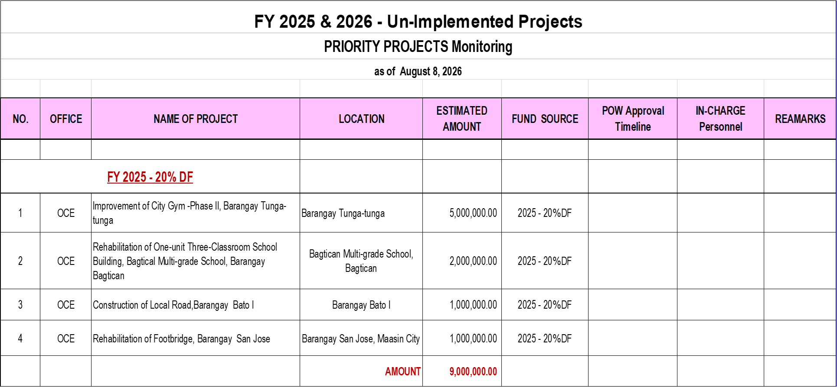
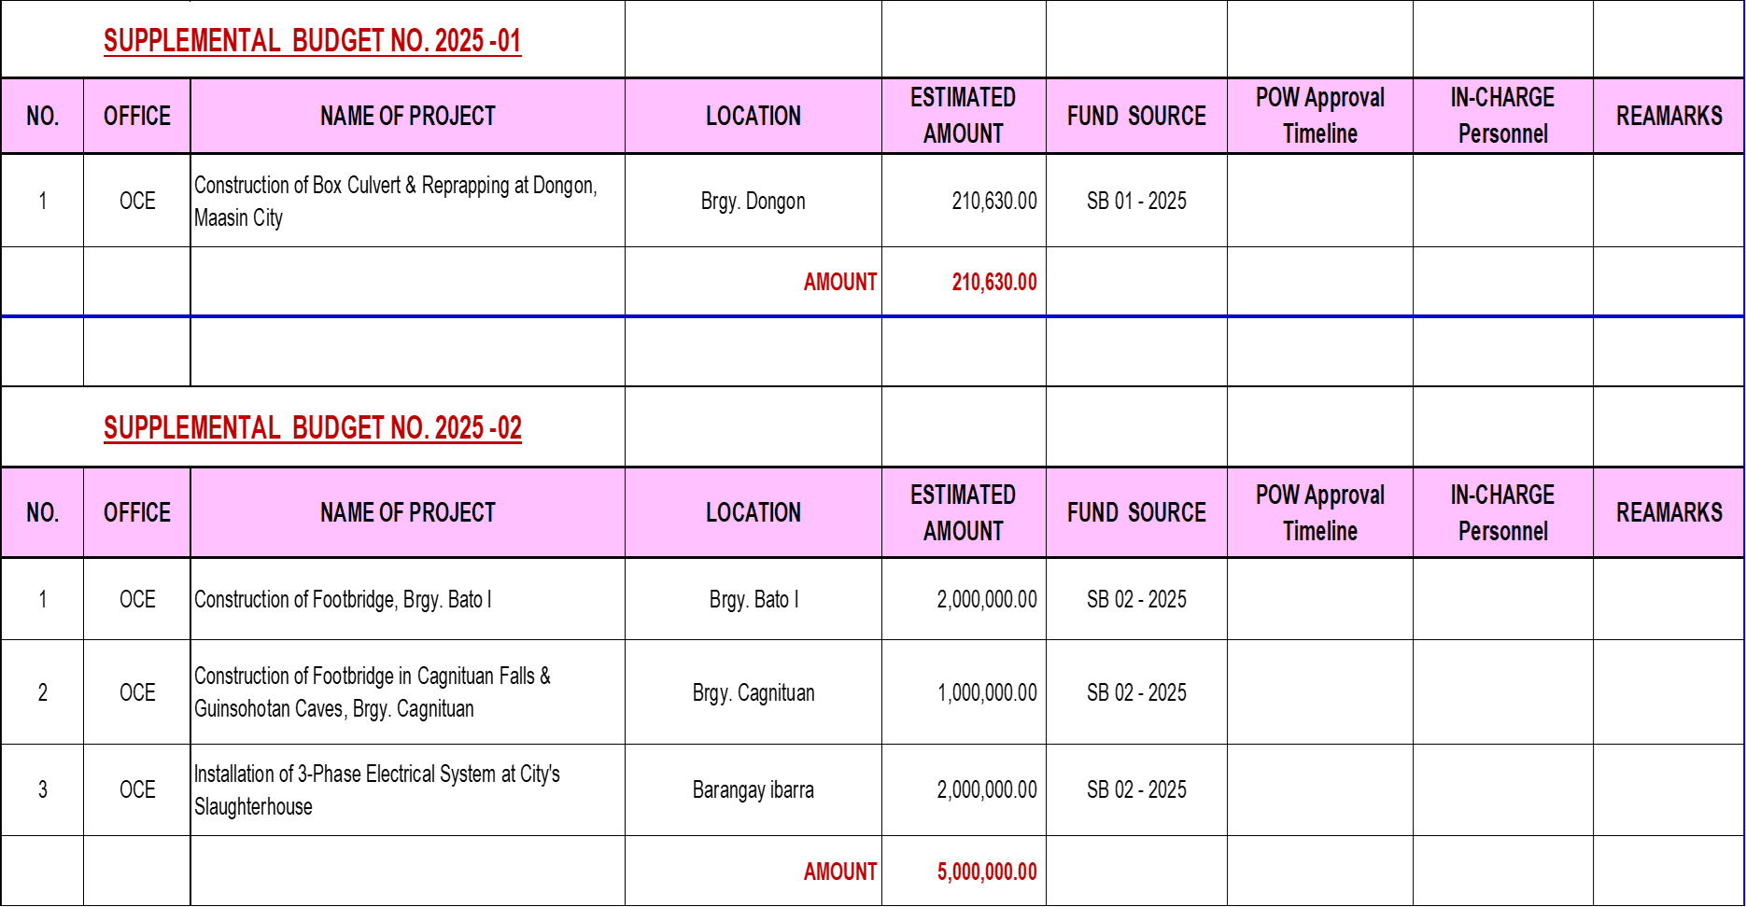
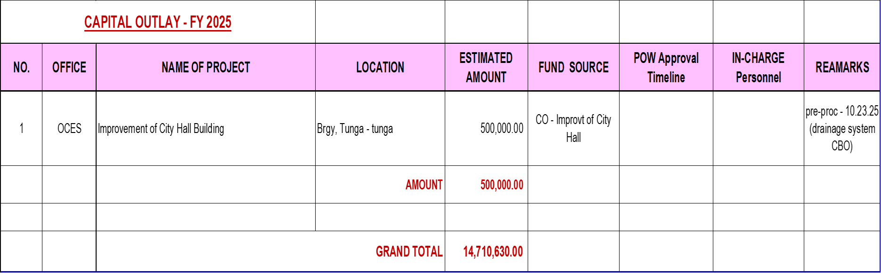
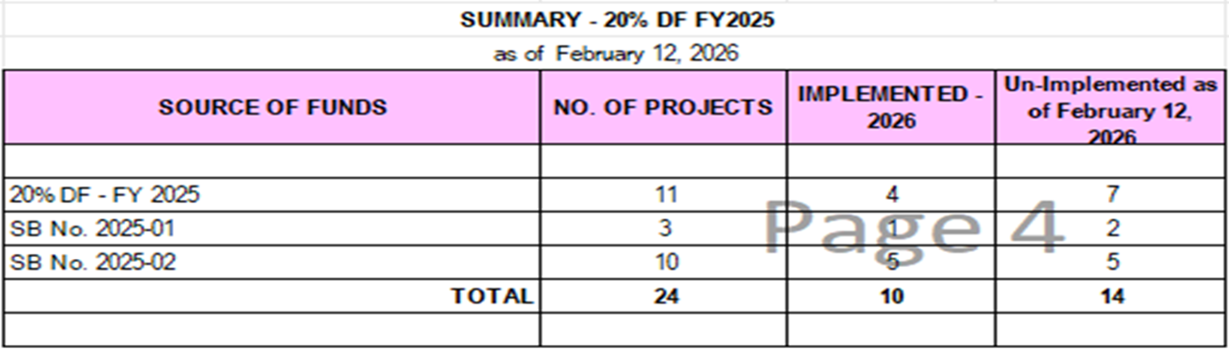
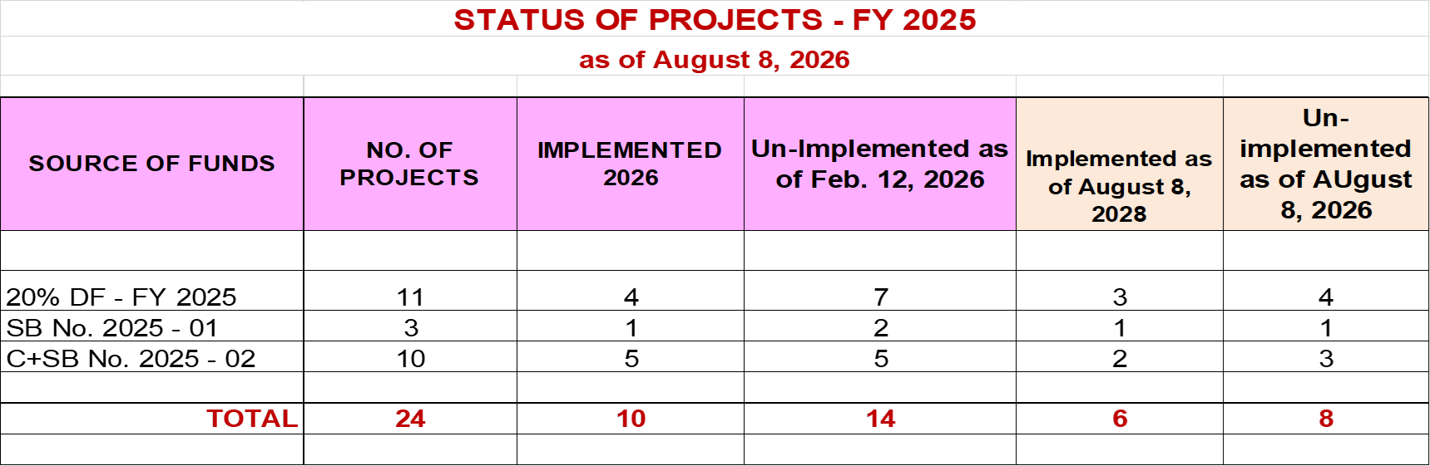

UN-IMPLEMENTED PPAs OF FY-2026

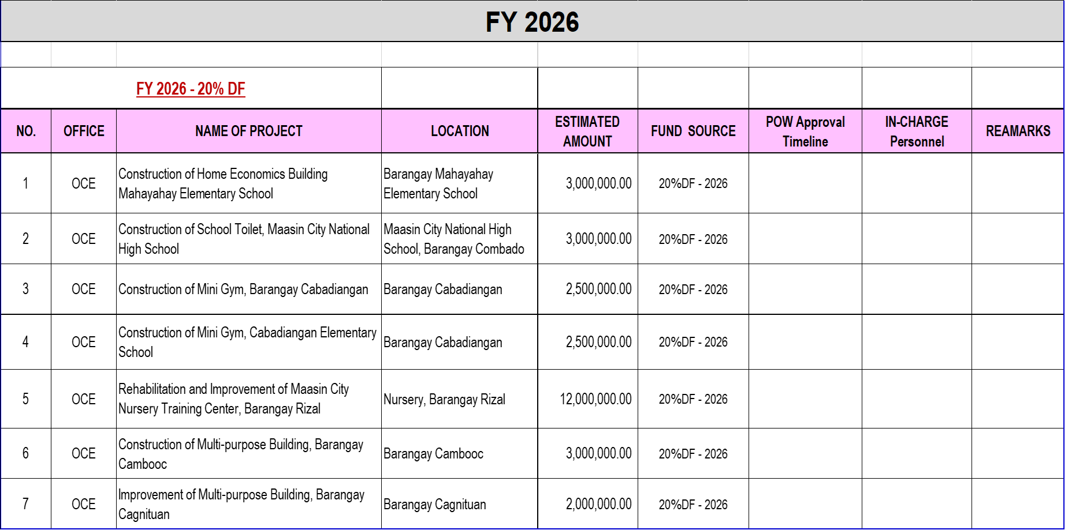
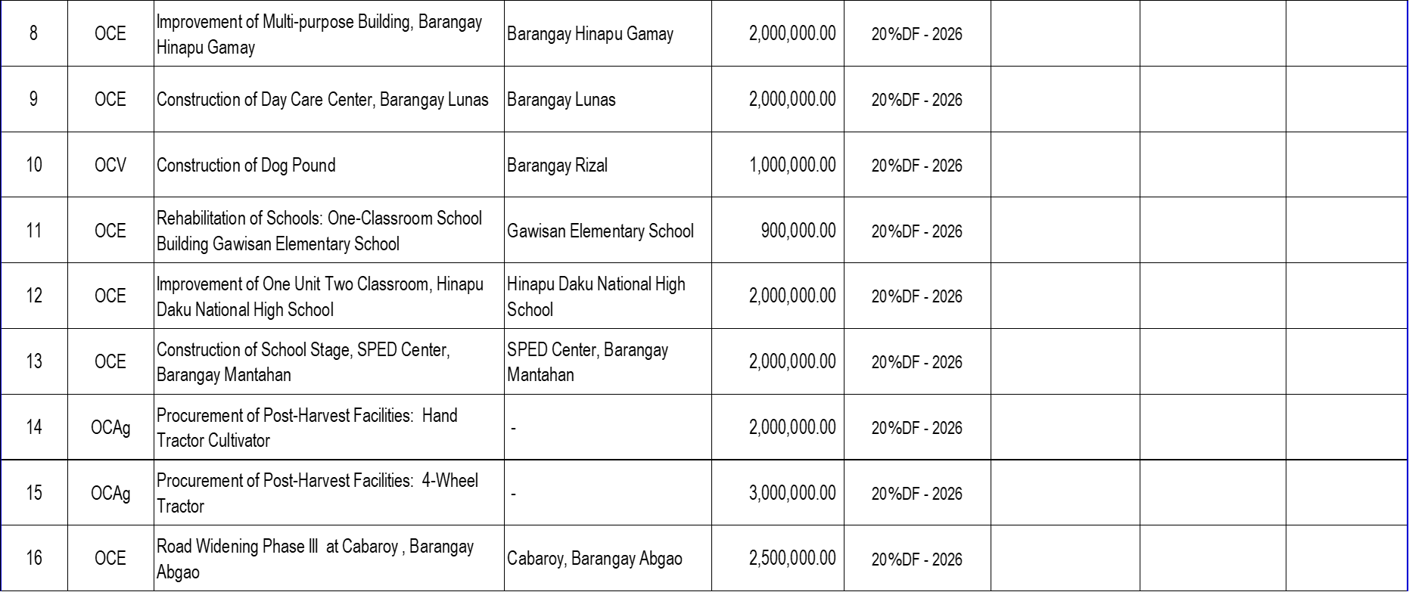
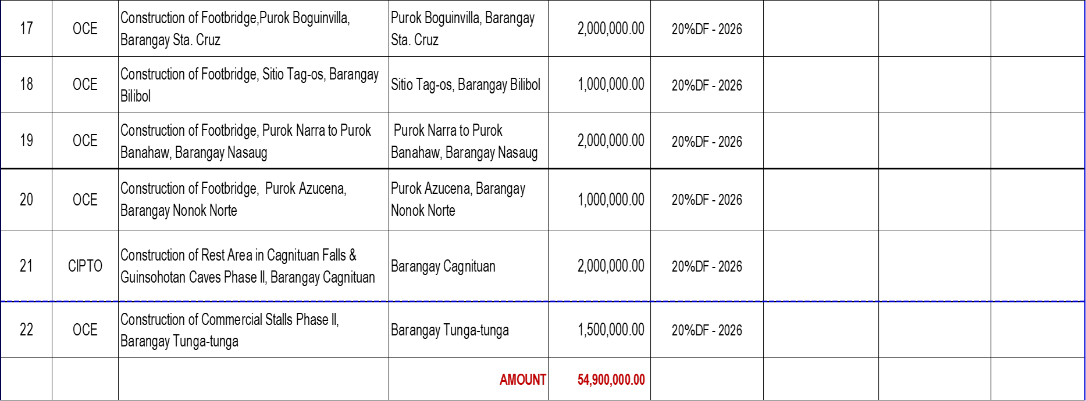
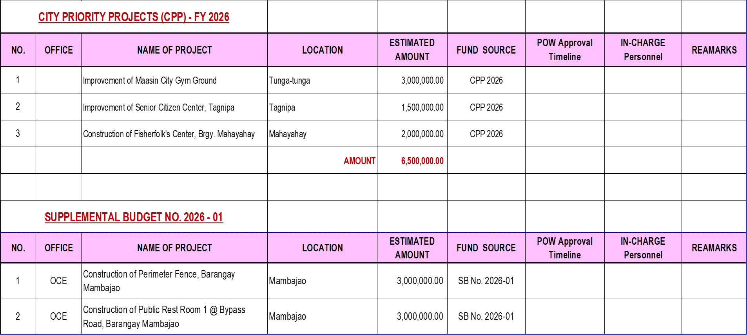
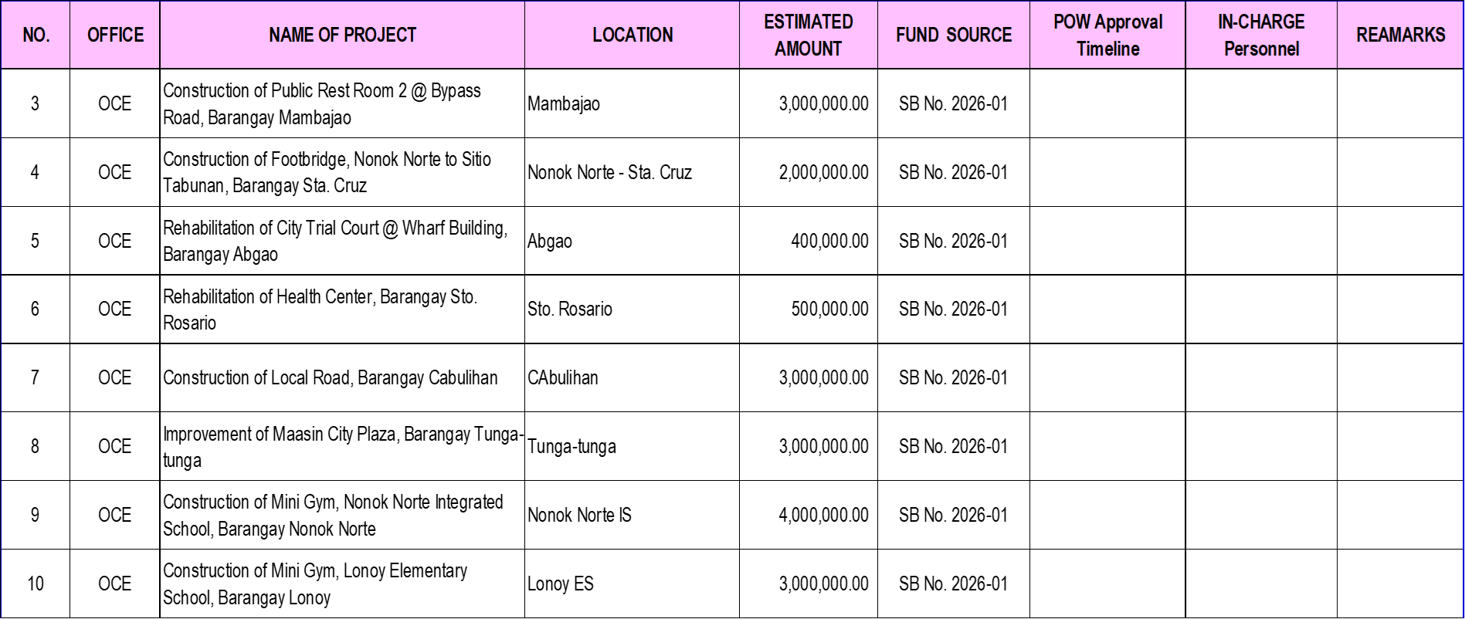
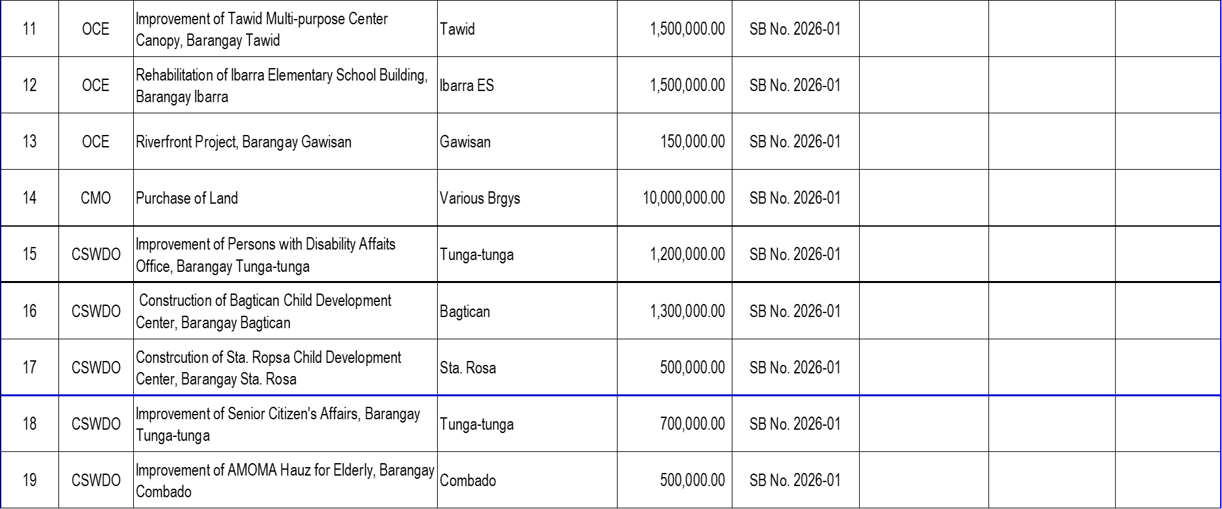
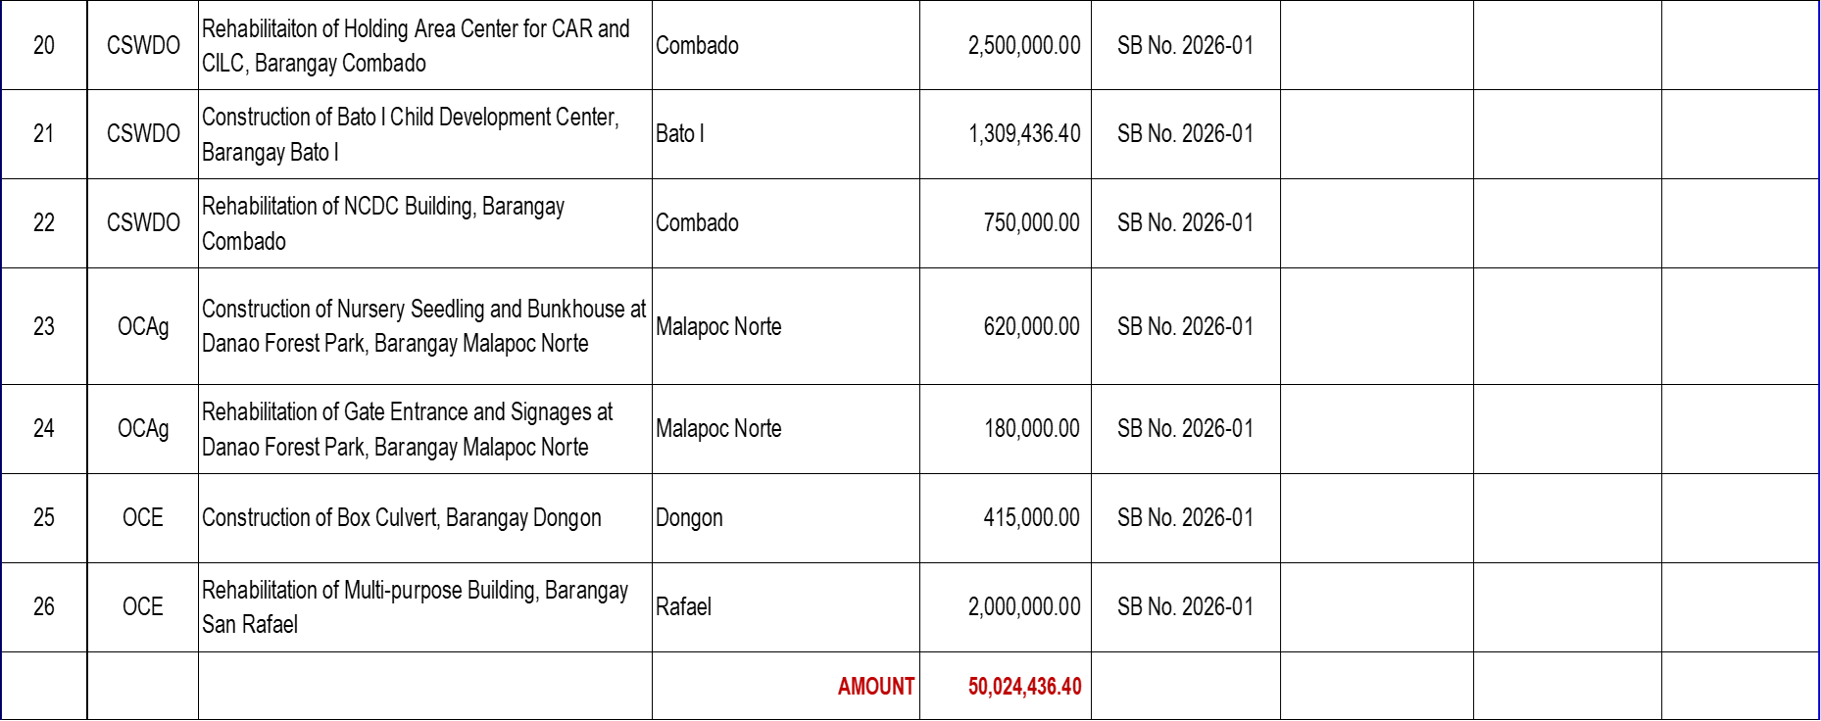

UN - IMPLEMENTED PROJECTS (FY-2025 & FY-2026)

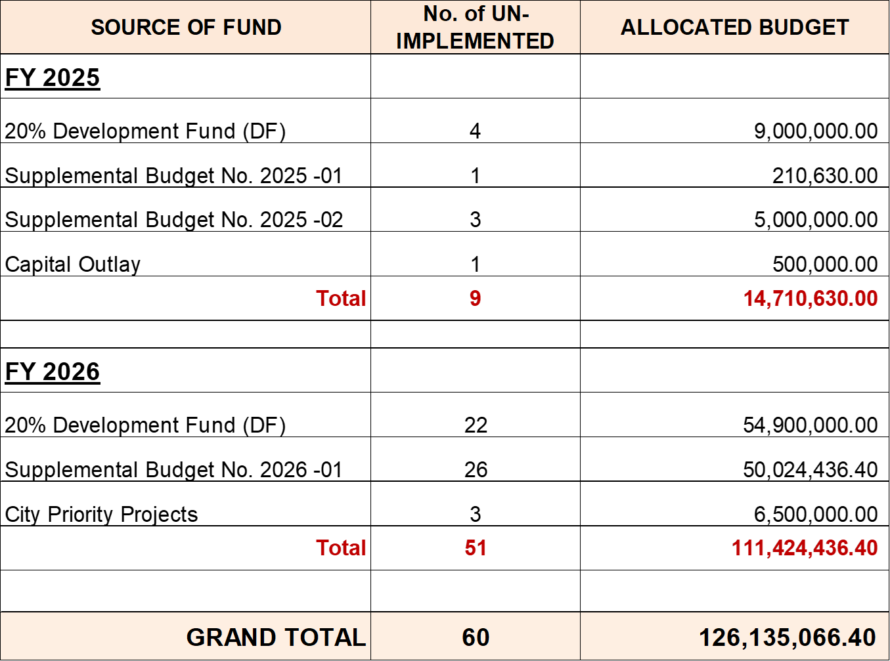

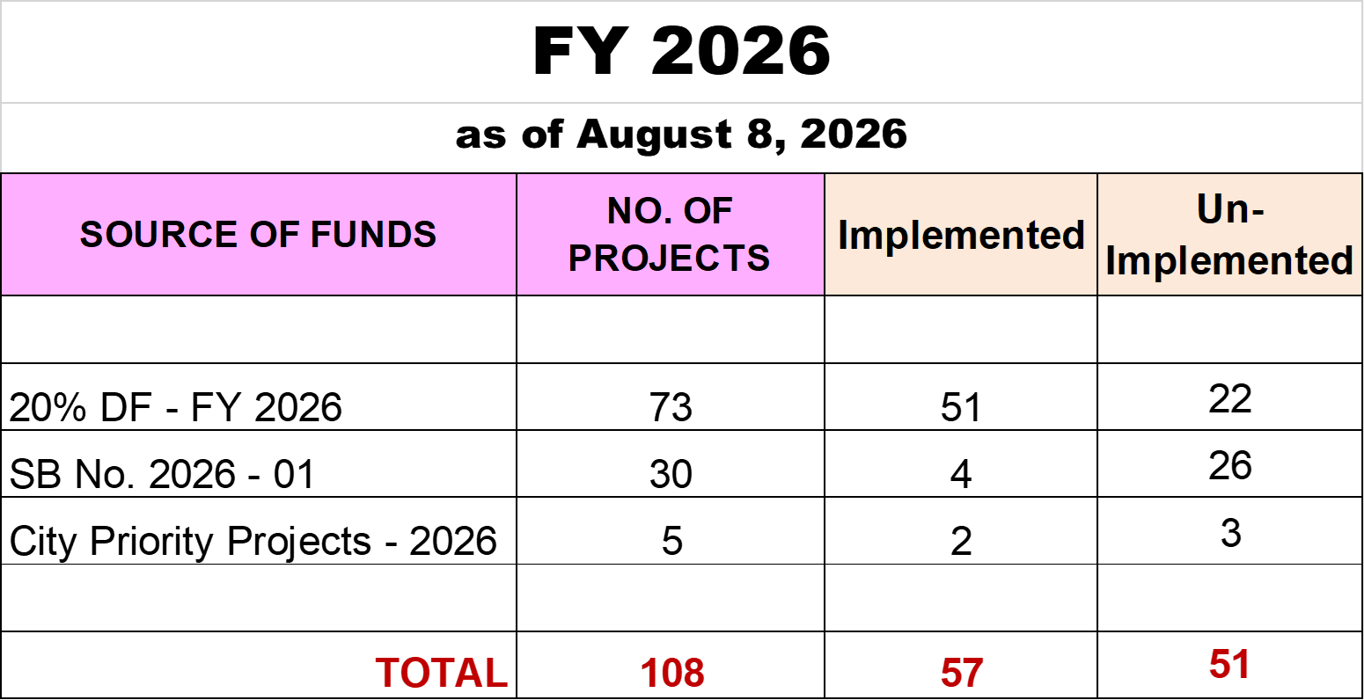

STATUS OF IMPLEMENTATION AS OF AUGUST 8, 2026
20% DEVELOPMENT FUND FY - 2026

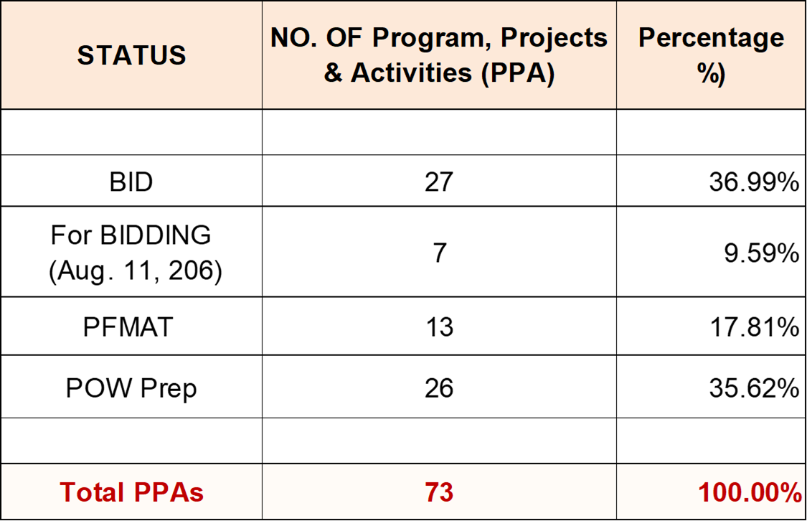

OTHER MATTERS:

Prepared by:

ENGR. EUFEMIA S. QUIRONG, SO2
Engineer II
City Planning And Development Office
PMC Secretariat


Approved by:

HON. DARYL M. COSTILLAS
Punong Barangay
Brgy. Abgao, Maasin City
PMC Chairman

